Design change document ver 0.2

Stuff not working
quick actions menu not working
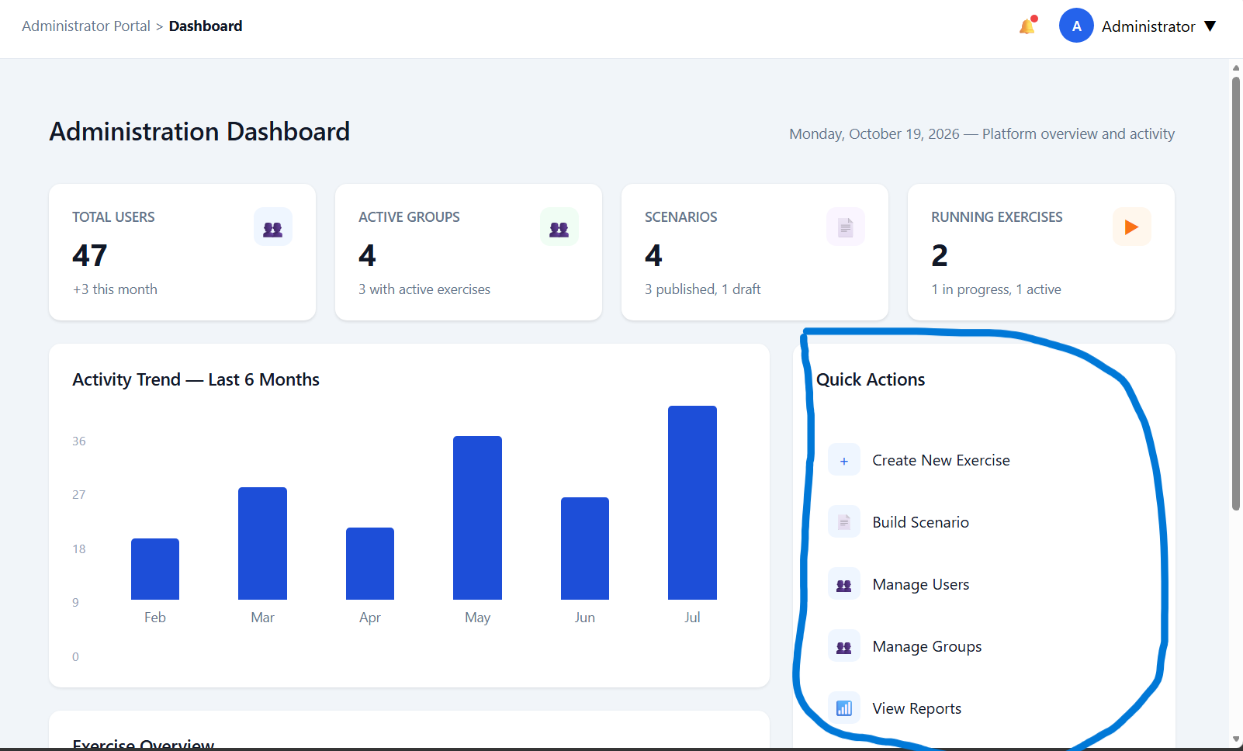
recent activity not working
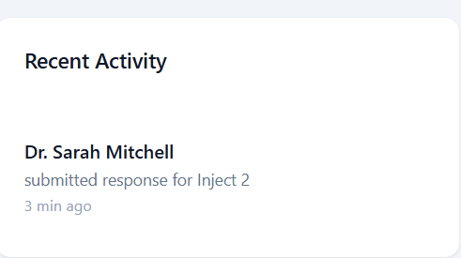
exercise overview does not reflect the actual scenarios/courses
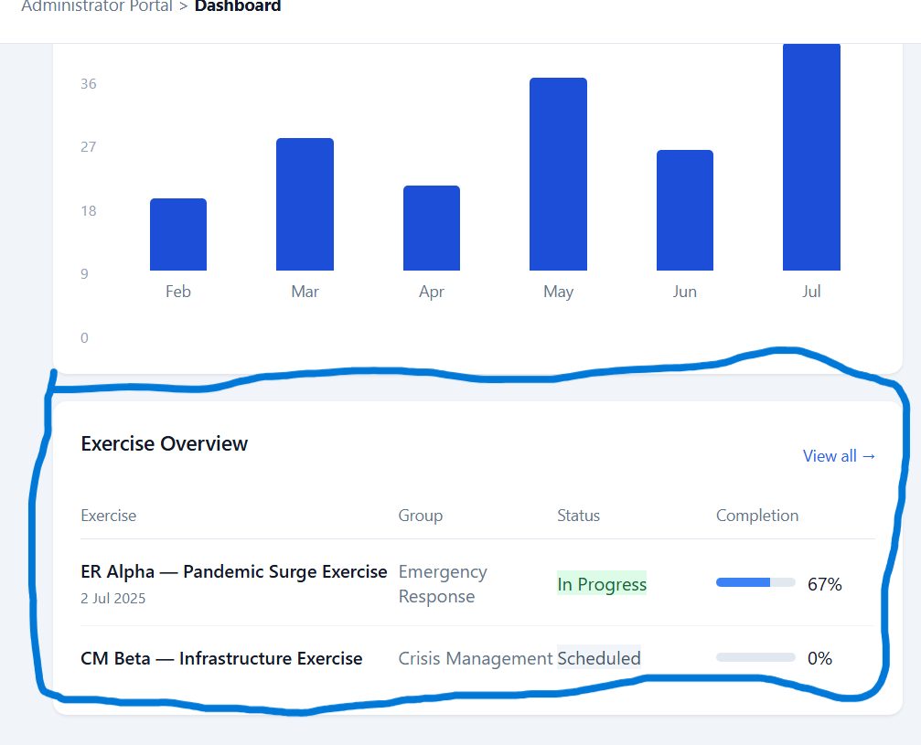

similarly to exercise overview in dashboard, the reports page does not accurately reflect the scenarios and should allow users to go straight to the exercises page. Can remove the graphs etc. if not doable. Then, allow hyper linking to each exercise from this page.
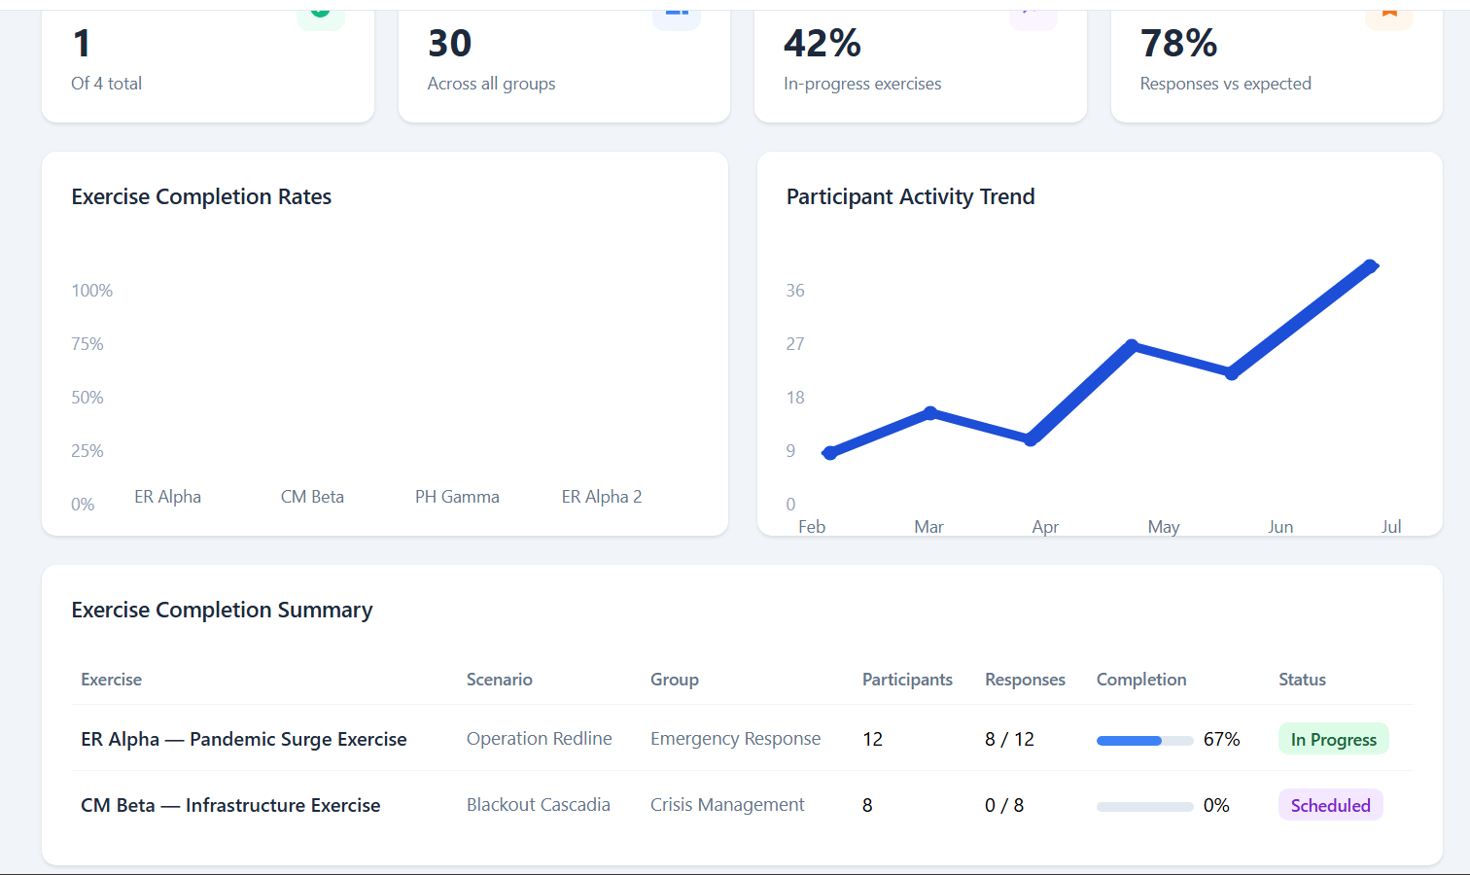

Stuff to add
marking injects page for admins, where admins can see users answers to injects and mark their answers.

Stuff to change
creating scenarios should let admin users create a category(crisis type) OR let admin users create in the pop-up window for the scenarios.
Possibly a simply + button to let users click to directly create from here, or a checkbox that opens a new field in the pop-up menu and stops users from interacting with the drop-down.
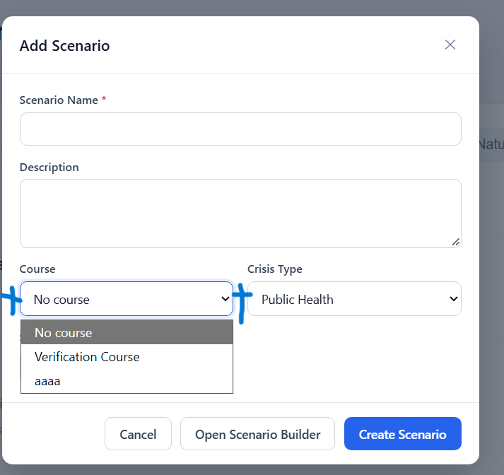
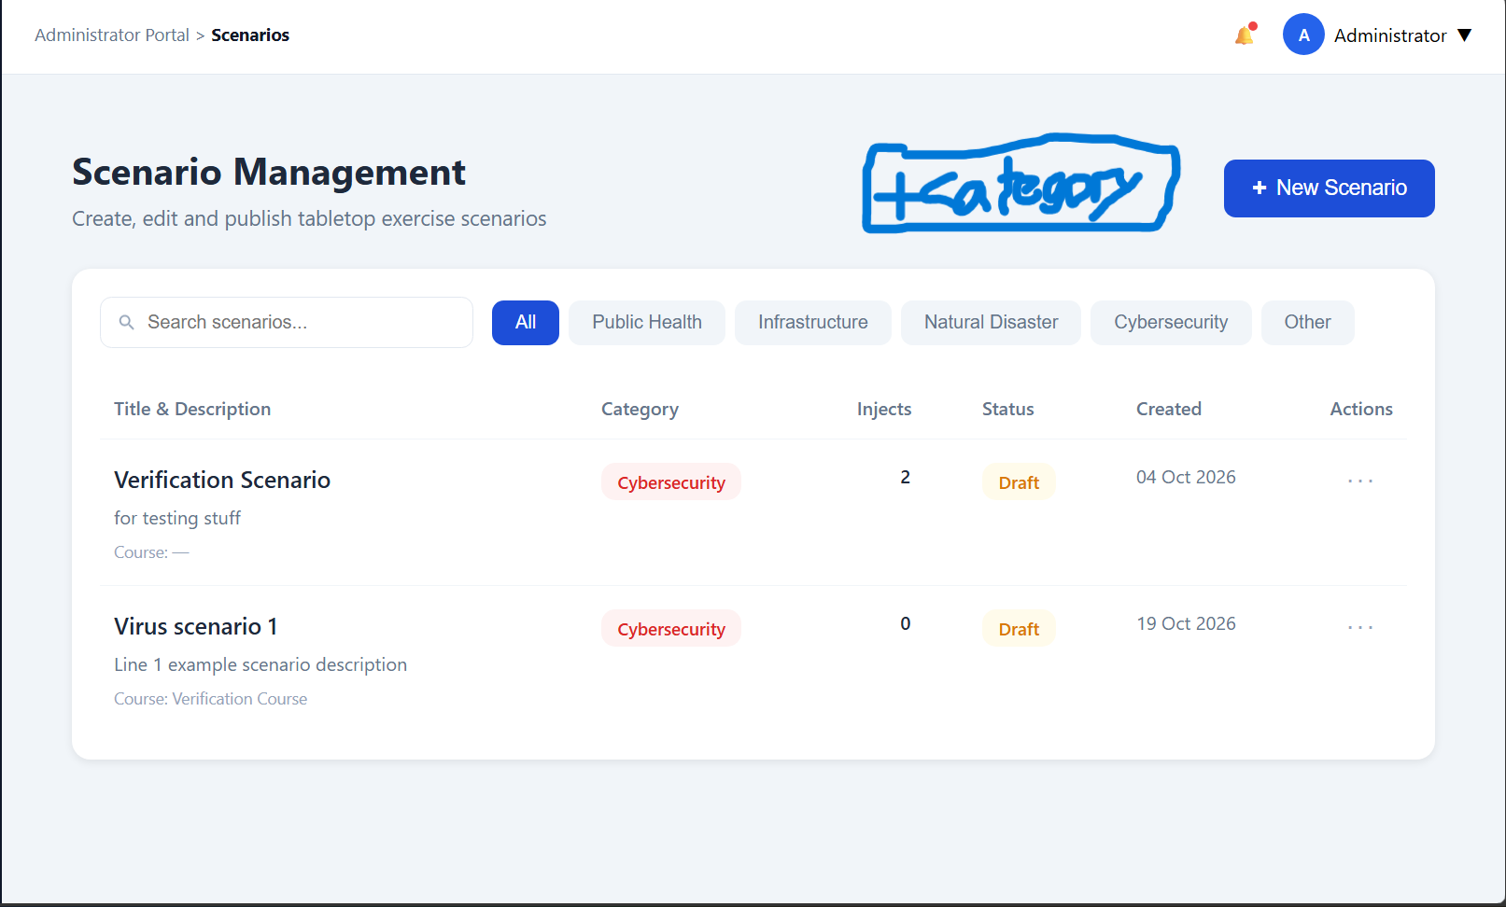
similarly, option to create a course in the pop up window instead of assigning it to existing courses.

*note hierarchy exists in this manner: crisis->scenario->course. crisis can exist independently without any existing scenarios created as a child of it, similarly for courses in relation to scenarios.*

Inject creation/edit can be added, alternatively create a new page for it if menu looks too messy.
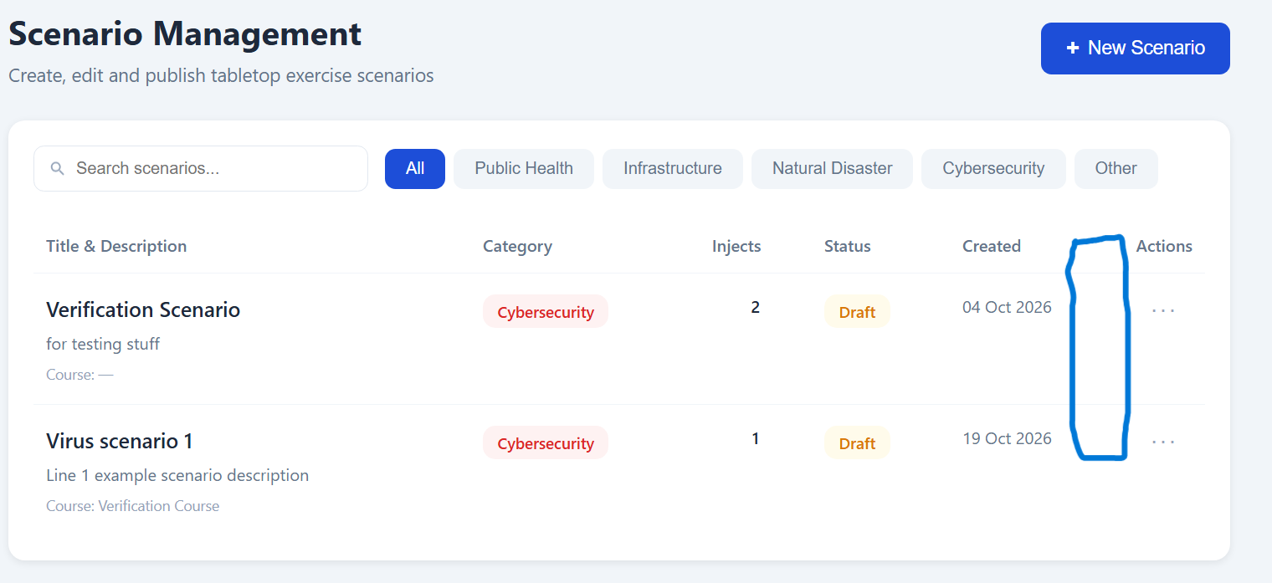

layout of page needs work, the menu, if too many categories, overflows out of the screen if window size is too small. needs to fit/go onto next line. can use containers etc. to scale with window size/aspect ratio.
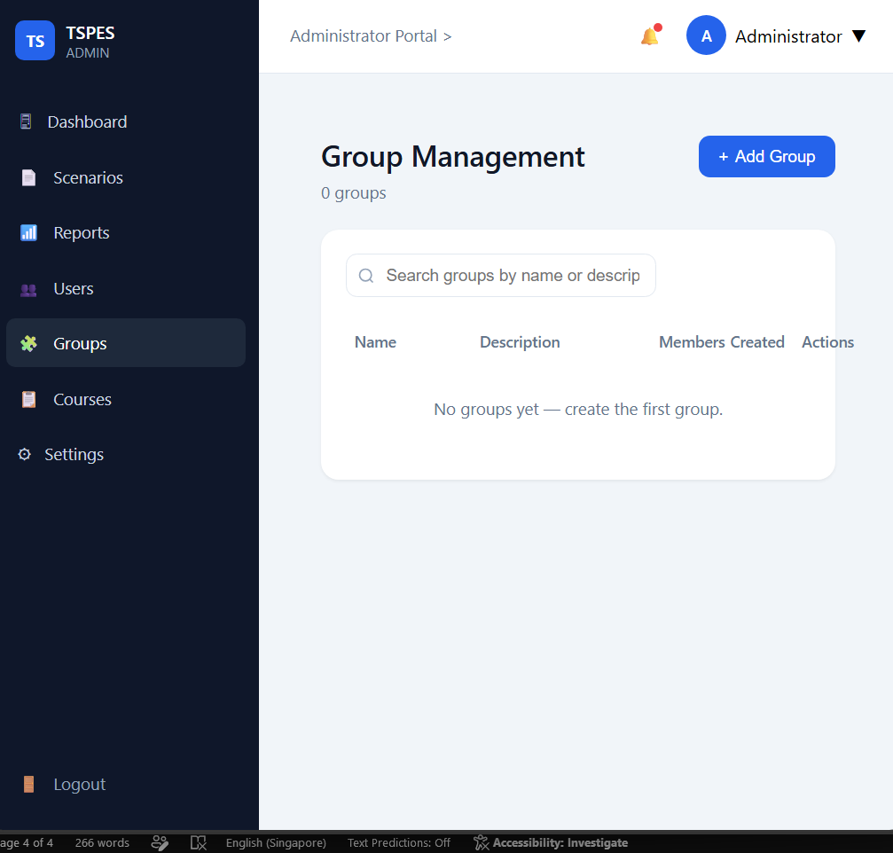
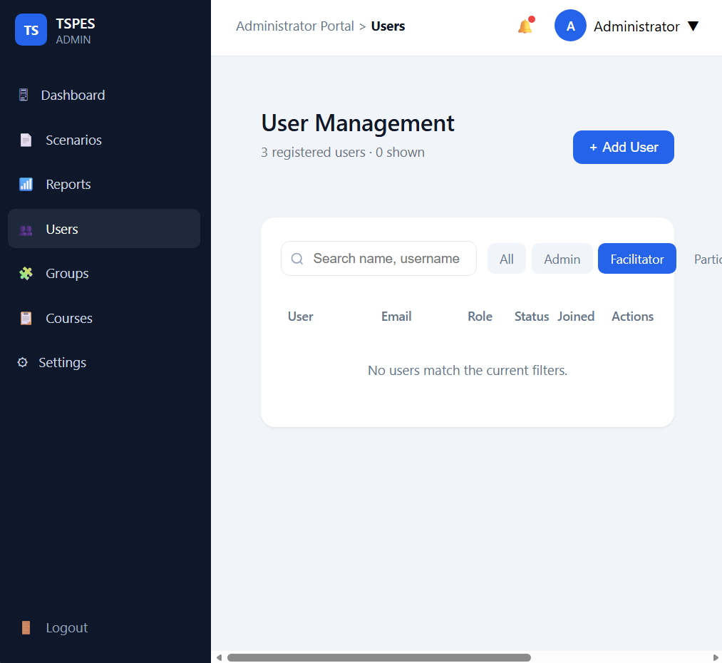

facilitator role is redundant and not in use. Admin to mark injects.
Allows admin to view a course, sort by category(crisis type), and click into a menu.
All UI items to follow current theme of TSPES. Images below are for UI element placement only.
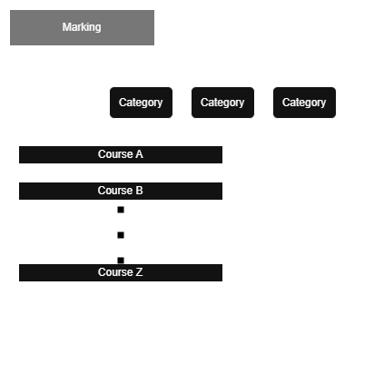

This will then open up into a menu for marking.
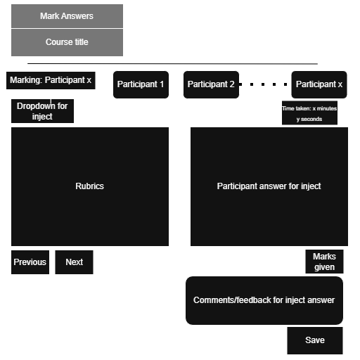
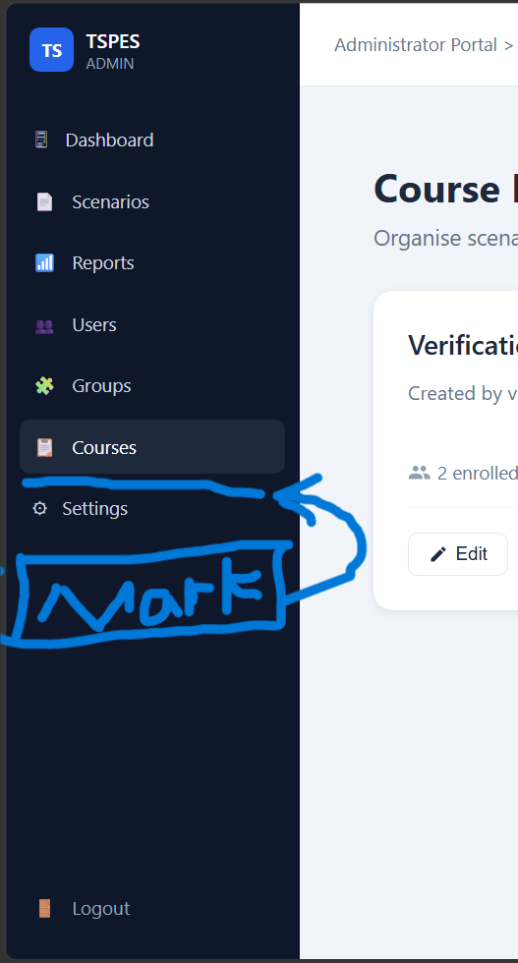

courses on menu bar should be higher up, above reports and below scenarios if possible. grouping together similar functions.
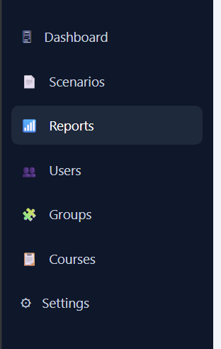

settings menu is slightly redundant. Possible to remove.

Remove graph on dashboard page, not in use. 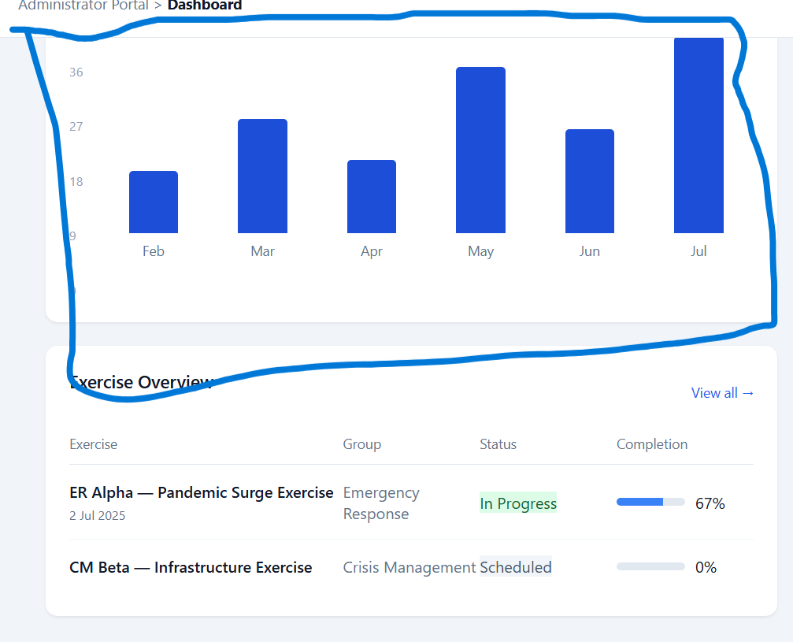

Optional design changes
For user ease of navigation, could be hyper-linked to allow users to navigate back to main menu. These are extra navigation options for users.
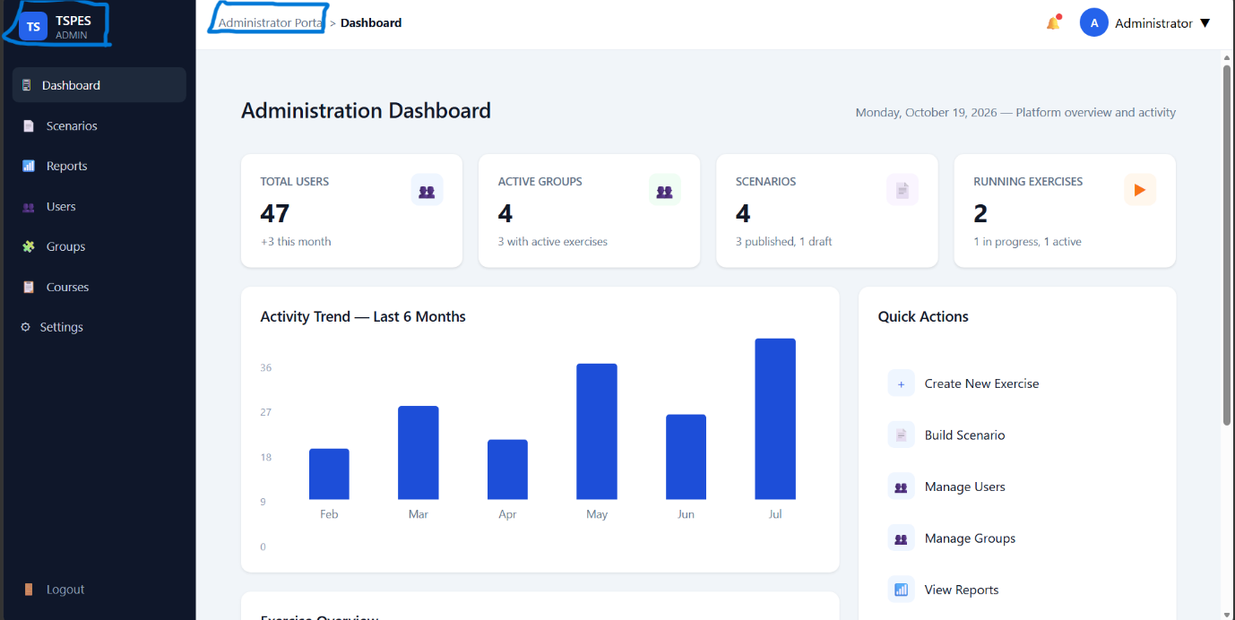

Accessibility/web-design view, mobile/tablet viewing compatibility.

Participant menu section
Time taken with a count up per inject should be added. To be used for marking as part of rubrics.
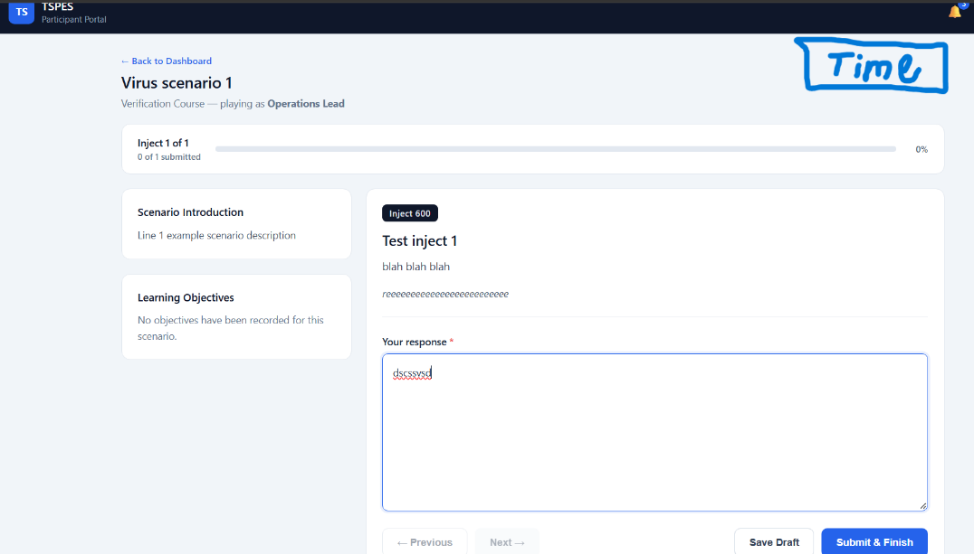

TSPES icon area can be made as additional back to dashboard/home button
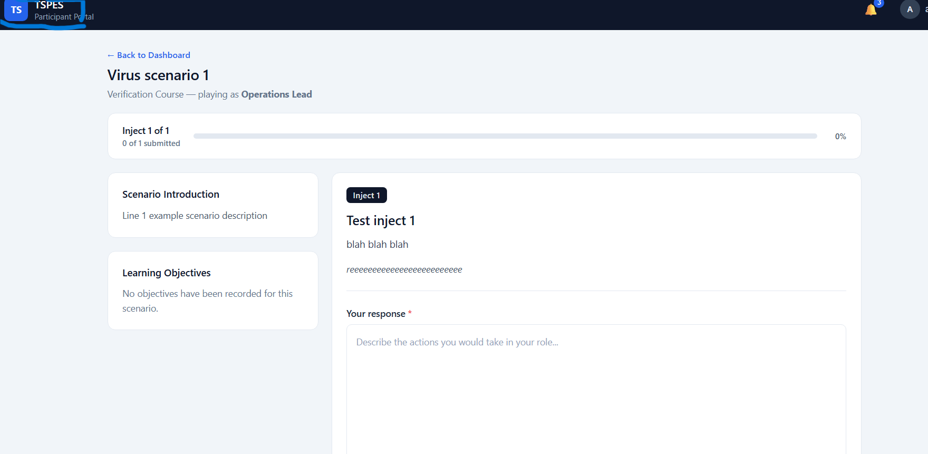

Learning objectives cannot be edited, can be deleted from displaying.
